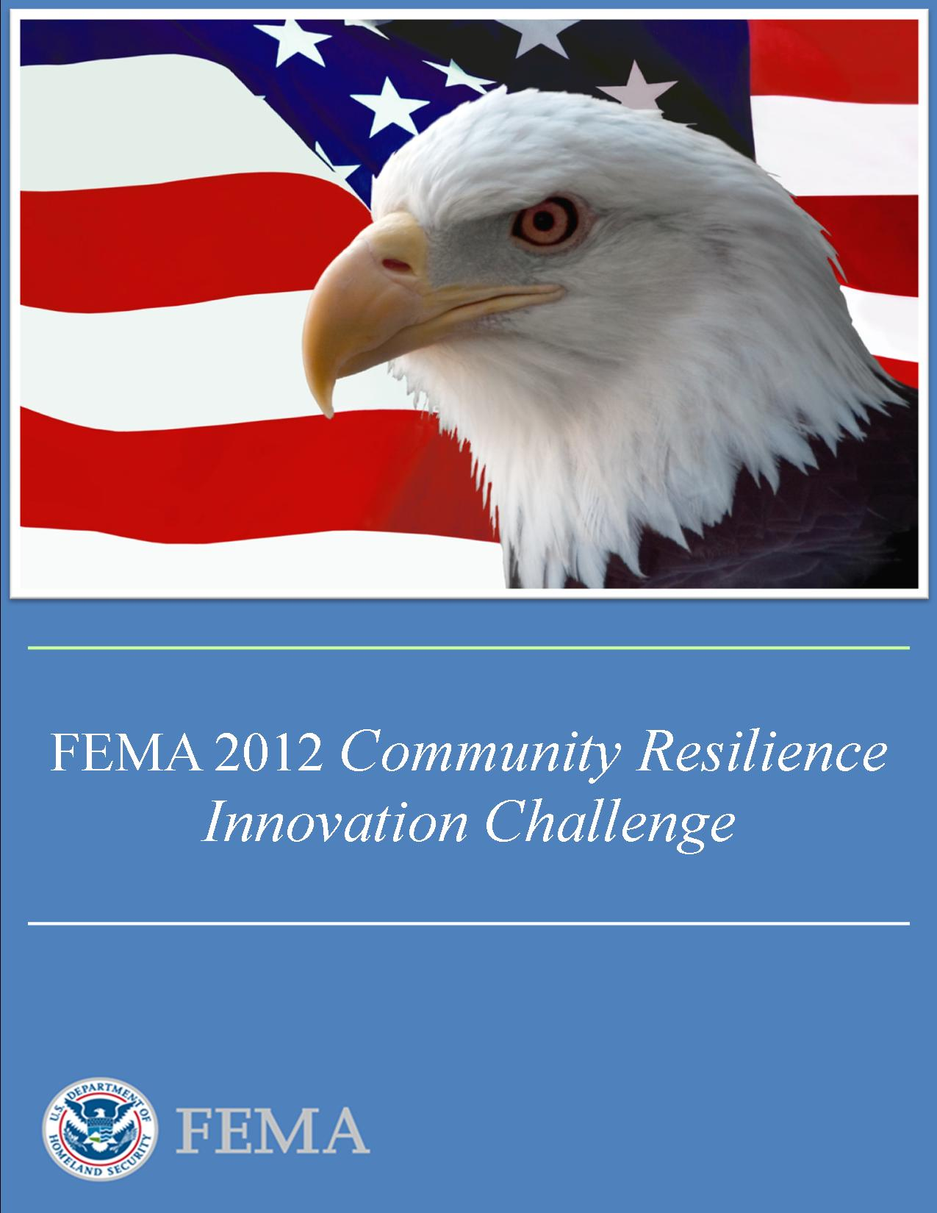

FEMA 2012 *Community Resilience Innovation Challenge*

2012 Challenge Program 2012 Challenge Program funded by: managed by:

A description... 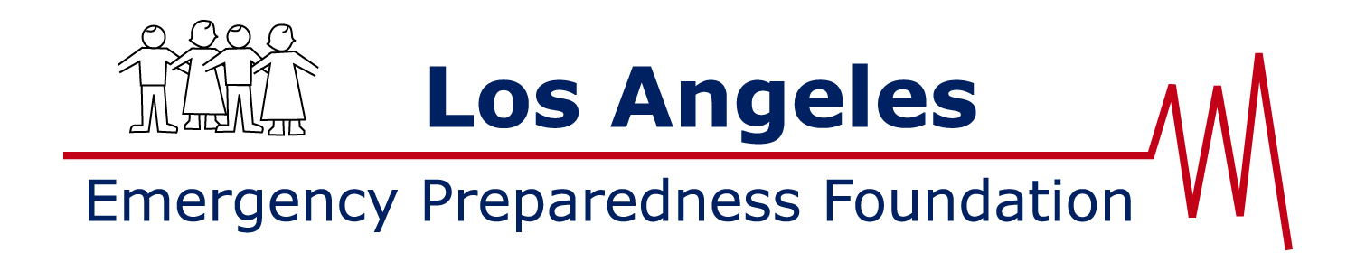

## Foreword

I am pleased to announce, in partnership with the Rockefeller Foundation, FEMA’s 2012 *Community Resilience Innovation Challenge*. This program, managed through the Los Angeles Emergency Preparedness Foundation, aims to identify and support best practices to strengthen community resilience. We view community resilience as the ability to adapt to changing conditions and be prepared to withstand, and recovery from, disruptions due to emergencies. In recognizing and supporting resilience initiatives, the key assessment areas will be the applicants’ demonstration that their approach to community resilience is innovative, collaboration based with community stakeholders, sustainable, repeatable in that it enables other communities to replicate their successful approaches, and beneficial to the community in measurable ways.

FEMA recognizes that a government-centric approach to disaster management is insufficient to meet the challenges posed by a catastrophic incident. To meet our preparedness goals, the Whole Community must be actively involved in all phases of the preparedness, response, and recovery cycle. As a concept, Whole Community is a means by which residents, emergency management practitioners, organizational and community leaders, and government officials can collectively understand and assess the needs of their respective communities and determine the best ways to organize and strengthen their assets, capacities, and interests. By doing so, a more effective path to societal security and resilience is built. As we work towards building a whole community approach to resilience, these 2012 Challenge program funds will serve as an anchor in that effort. I am hopeful that we will have a wide array of applicants including, but not limited to, state, local, tribal, and not for profit organizations. The number of selected recipients and funding amounts will depend on the number and types of proposals received. The Los Angeles Emergency Preparedness Foundation will begin vetting submitted applications this October with a target for the first distribution of funds in November.

Much can be learned and leveraged by tapping the expertise, experience, and thought leadership of emergency preparedness and response officials nationwide. We hope this widely cast net will yield many innovative proposals that will better prepare communities for meeting the needs of its citizenry in an emergency. We look forward to selecting the 2012 Challenge program recipients and to fostering a whole community approach to emergency management resulting from this effort. Thank you for your interest in the 2012 *Community Resilience Innovation Challenge*.

W. Craig Fugate

Administrator

FEMA

FEMA 2012 Community Resilience

Innovation Challenge

## 2012 Challenge Overview:

### Fostering community resilience by identifying needs; mobilizing partners; and creating innovative, motivational, and effective solutions that can be grown, sustained, and replicated.

Continuing threats from terrorist attacks and natural disasters challenge local communities to develop a collective, local ability to withstand the potential initial impacts of these events, respond quickly, and recover and rebuild the community to an enhanced level of resiliency. How communities achieve this collective ability calls for innovative approaches to strengthen existing practices, institutions, and organizations that help make local communities successful during normal times, and leverage those social and economic strengths to prepare for a lead role if an incident occurs.

The 2012 Challenge program will support a broad range of creative activities and may include organizing resources, partnerships, and leadership activities among small neighborhood groups, civic or faith based organizations, private sector entities, or educational institutions. Particular focus will be placed on reaching across social sectors, while a specific goal will be increased local dialogue that includes the sharing of information about local risks and the vulnerabilities of and consequences for local residents and their well-being. Activities can range from establishing a way to train neighborhoods to prepare and take care of themselves and others in an emergency situation to co-hosting initiatives with the private sector to actively involve businesses and organizations to improve preparedness programs, from involving children and youth through educational programs and activities to sponsoring drills for local hazards.

The 2012 Challenge program will support both existing and new initiatives:

* Existing Initiatives

Support for innovations that have already established a level of competence and performance in bringing local residents together to confront local problems or to expand opportunities. The 2012 Challenge program will draw attention to and publically recognize local success stories and promising practices, and provide financial support to further advance resilience capacities into these community activities.

* New Collaborations

Assistance with catalyzing newly formed networks, groups or institutions that come together specifically to design and test innovative approaches to community resilience. The 2012 Challenge will, in particular, focus on initiatives that bring relatively small, local neighborhood organizations together with established institutions and organizations to further community resilience.

FEMA has selected and awarded a grant to the Los Angeles Emergency Preparedness Foundation (a 501c3 nonprofit foundation) to manage the 2012 Community Resilience Innovation Challenge program, and will be the point of contact for all Challenge program applicants and selected program funding recipients.

Funding for this initiative has been provided by the Rockefeller Foundation.

## 2012 Challenge Funding:

* Selected projects will be funded up to a maximum of $35,000.
* No financial match is required.
* Funds will be paid directly to the selected project agency, institution, business entity, association, organization, or group.
* Funds will be paid via check or electronic funds transfer.
* Total program funding, requirements, and timing may be adjusted at the discretion of FEMA.

## Eligible Applicants:

* Agencies, institutions, business entities, associations, organizations or groups (Public or Private Sector) operating within the local jurisdiction where the project will be conducted are eligible. Awards to individuals will not be considered.
* Only projects within the United States of America and United States of America territories will be considered.
* Applications must be complete to be considered for funding, including all questions and program/project budget information.

## Program Requirements:

* All projects must start (documented initiation or kickoff) within 30 days of receiving funds.
* Challenge funds must be fully utilized within 1 year of receipt.
* All selected applicants will be required to submit a brief program summary report (one year from the date of funding) detailing major project activities, impact, and lessons for scalability to other communities.

## Application Deadline:

* Postmarked **October 26, 2012** or emailed by 11:59 pm PDT.

## Notification:

* Selected recipients will be notified by **November 23, 2012.**

## How to apply:

* Complete the FEMA 2012 Community Resilience Innovation Challenge Application and email to: **Application@ResilienceChallenge.org**
* Or mail a printed copy to:

**2012 Community Resilience Innovation Challenge**

**Los Angeles Emergency Preparedness Foundation**

**350 South Figueroa Street, Suite 437**

**Los Angeles, CA 90071**

## Questions:

Please contact the Los Angeles Emergency Preparedness Foundation if you have any questions concerning the FEMA 2012 Community Resilience Innovation Challenge or this application: Email questions to: **Questions@ResilienceChallenge.org**

You can also reach us by phone at: 213-325-3035.

## 2012 Challenge Evaluation Criteria:

Evaluation criteria include, but are not limited to, the following factors:

1. **Innovation:** The creativity and effectiveness of the proposed strategy and methods to increase community resilience.
2. **Collaboration:** The process where people or organizations work together to realize common goals by sharing knowledge, learning and building consensus.
3. **Project Sustainability:** The ability of a project to successfully function, gather support, adapt, obtain funding, and deliver benefits from initial start-up to long-term operation.
4. **Replication:** The transferability of the project to other communities.
5. **Benefits:** The benefits to be received and milestones accomplished if the project is to be considered successful.

## Frequently Asked Questions (FAQ):

Q: *If our program/project is selected to receive 2012 Challenge funds, how long will it take from the time we are notified to the time we receive our payment?*

A: The payment process will take approximately 30 to 45 days and funds will be sent by check or electronic funds transfer. All programs/projects must start within 30 days of receiving funds.

Q: *Are any matching or supplemental source of funds required to qualify for the 2012 Challenge?*

A: No additional source of funding is required to apply for the 2012 Community Resilience Innovation Challenge or to participate in the program.

Q: *Can we apply more than once for the 2012 Challenge?*

A: The 2012 Community Resilience Innovation Challenge is limited to a maximum of one Challenge payment per selected applicant.

Q: *Will 2012 Innovation Challenge winners be highlighted by FEMA as part of the program?*

A: 2012 Community Resilience Innovation Challenge programs that are selected for funding and successfully implemented will become reference communities and will receive recognition for their success and efforts in building community resilience.

Q. *What are the reporting requirements once we receive our Challenge funds?*

A. Quarterly status reports will be required during the life of the project, including budget spend down, and a final report is required upon completion.

FEMA 2012 Community Resilience

Innovation Challenge

# Application Form:

Please provide typed responses to all questions below. Completed applications should be submitted to the Los Angeles Emergency Preparedness Foundation per the instructions on the last page.

## General Information:

1. **Name and Primary Mission of the Agency, Association, Organization, or Group (Public or Private Sector) applying for Challenge funding**:
   1. Official Name: **HacDC**
   2. Mission or Function (*maximum 100 words/600 characters*):

**HacDC is a community organization in Washington, D.C. devoted to collaboration in the creative use of technology, hosting free and open activities to share knowledge, skills, and ideas. HacDC activities can be divided into three categories: educational programs, community service, and technical and research projects. Educational programs encompass talks, classes, joint projects, and workshops. HacDC’s community service marshals the organization’s technological knowledge to benefit the surrounding community. Technical and research projects have a range of topics and subject areas.**

1. **Program/Project Point of Contact** (by submitting this application, the point of contact confirms that they represent the implementing organization and will comply with the terms of the 2012 Community Resilience Innovation Challenge):
   1. Name: **Ben Mendis**
   2. Title: **Vice President**
   3. Organization: **HacDC**
   4. Mailing Address

Address line 1: **1525 Newton St. NW**

Address line 2:

City, State, Zip: **Washington, D.C. 20001**

* 1. Phone number(s): **301-244-8678**
  2. Email address: **ben.mendis@gmail.com**
  3. Web site: **www.hacdc.org**

## Program/Project Information:

1. **Program/Project Name** (*please do not use acronyms):*

**DC Community Wireless Networks**

1. **Please provide a two sentence summary of your 2012 Community Resilience Innovation Challenge program/project**. This description should accurately and succinctly convey the essence of the project. Should your project be selected to receive 2012 Challenge funds, this description will be used for recognition and press purposes. (*maximum 75 words/450 characters*)

**Our project will collaborate with existing community wireless initiatives in order to create reliable communications networks for disaster conditions. These networks will allow residents to share information across neighborhoods using their own mobile phones, even when the power grid and cellular networks have failed.**

1. **Is the proposed program/project**: (*please check one*)

* 1. an Expansion of an Existing Initiative **or**  a New Collaboration

1. **Program Coverage Area**
   1. Please indicate the estimated local population (amount of people) that may benefit from the project: **Based on the 2010 census data, the combined population of Mt. Pleasant and Columbia Height is approximately 52,000. All residents in these neighborhoods will benefit from the networks and the potential reach is even more significant when considering visitors and non-residents.**
   2. Identify specific segments of the community that will be targeted, *if applicable* (e.g., youth, those with access and functional needs, non-English speaking): **According to the 2010 census data, 35,100 residents in Mt. Pleasant and Columbia Heights are from minority communities. As we continue to identify and engage local community institutions throughout the neighborhoods, these organizations serve as anchors among the diverse populations of the neighborhood. From youth organizations to Baptist churches, our extensive outreach approach strives to ensure the network is both inclusive and representative of all local communities.**
2. **Please summarize your 2012 Community Resilience Innovation Challenge program/project touching on each of the points below**.
   1. Describe the scope of your proposal, including how it may impact or contribute to community resiliency.
   2. Describe what is innovative about your proposal.
   3. Who will you collaborate with to achieve the goals of the project?
   4. How will you sustain this project and how could it be replicated in other communities?
   5. Describe how these limited funds will help achieve the goals of your project.
   6. How will you measure the impact of the project?

(*Do not exceed 500 words/3000 characters collectively for items a-f*)

**In a disaster scenario, when traditional communications networks fail, finding loved ones, taking stock of supplies and coordinating with rescuers is a real challenge.**

**Our project addresses this issue directly. Rather than rely on traditional infrastructure, our project employs devices which are already abundant in any disaster-affected community: wireless internet routers and mobile phones. Using an innovative networking technology, our project allows residents to communicate with each other via the wireless routers -- allowing residents to not only receive but *share* critical information in a disaster.**

**These kinds of community networks are incredibly resilient. A few dozen wireless routers mounted on rooftops can cover an entire neighborhood, and residents' mobile phones can operate over the network without installing any new software. Most importantly, each of these devices can operate independently of the power grid and cellular network. The routers -- which use about as much power as an alarm clock -- can last for days solely on battery power.**

**Our project involves the combined efforts of local technologists and community groups. HacDC's Project Byzantium (based out of St. Stephen's church on the border of the Mt. Pleasant and Columbia Heights neighborhoods) will collaborate with local organizers who are already working with residents, community groups and local businesses to mount routers on rooftops in their neighborhoods. To date, there are fifteen routers already in operation and being used by local residents.**

**With additional funding, these networks could be expanded to cover (and interconnect) both neighborhoods. The wireless routers are relatively inexpensive ($80 each), however, they need to be equipped with batteries and mounted securely, which requires additional hardware and configuration. In partnering with the Mt. Pleasant Solar Cooperative, we intend to further extend the resilience of the network by establishing charging stations for residents' cell phones and router batteries.**

**Both the Mt. Pleasant and Columbia Heights networks place a strong emphasis on being independently replicable and sustainable. Organizers focus on community outreach and encourage residents to participate in installations and planning meetings in order to facilitate skill-sharing. Both networks encourage a sustainable model of individually-owned infrastructure – each host is encouraged to operate and maintain their own router.**

**The project's main focus is to connect residents of these communities using a network which can function in a disaster scenario even without access to the power grid or cellular networks. Its impact can be accurately measured by the number of rooftop-mounted routers, the geographic coverage throughout the network, the use of local applications offered over the network, and the number of network users. The ability to communicate within and across neighborhoods will greatly enhance the resilience of these (and other) communities.**

1. **Please provide a budget for how 2012 Challenge funds will be used.**
   1. What is the estimated project budget breakdown? *If a category is not applicable, please write $0 (zero) in the Amount column*.

|  |  |
| --- | --- |
| *Category* | *Amount* |
| Personnel | $ 10000 |
| Supplies and Project Materials | $ 12000 |
| Outreach and Marketing | $ 11000 |
| Travel | $ 2000 |
| Other (*please specify*): | $ |
| Total: | $ 35000 |

* 1. Will additional funds be needed to achieve sustainability?

No

Yes. *Please provide estimated amount and potential source*  (*maximum 75 words/450 characters*):

* 1. Will in-kind resources be used to implement your program/project?

No

Yes. *Please provide estimated amount and source:* (*maximum 75 words/450 characters*): **HacDC will continue to develop Byzantium, and will also work in conjunction with the Open Technology Institute (OTI) on local application development. The Mt. Pleasant Solar Cooperative will provide access to their solar energy grid.**

# Reference Letter(s) – Optional

**Please submit up to 2 reference letters**

Letters should reference the Agency, Institution, Business Entity, Association, Organization or Group that will be performing the proposed community resilience program/project.

# Submit Application

Your completed application will include:

1. Completed Application Form
2. Letters of Reference (*optional*)

Submit completed application:

* By Email:

**Application@ResilienceChallenge.org**

**OR**

* By postal mail:

**2012 Community Resilience Innovation Challenge**

**Los Angeles Emergency Preparedness Foundation**

**350 South Figueroa Street, Suite 437**

**Los Angeles, CA 90071**

# Questions:

Please contact the Los Angeles Emergency Preparedness Foundation if you have any questions concerning the FEMA 2012 Community Resilience Innovation Challenge or this application:

* Email questions to: **Questions@ResilienceChallenge.org**
* Or please call us at: 213-325-3035
* Brent Woodworth – 2012 Challenge Program Executive

**Thank you for your support and commitment to Community Resilience.**